System Specification
MOS

Document name | MOS_SysSpec_v0.1
Version | 0.1
Date | 10.3.2022
State | Initial
Confidentiality | RESTRICTED
Document No. | SYSSPEC-MOS-0001
Distribution | Everone

HTL Spengergasse, Team Zyzz
Table of Contents
1 Introduction 3
1.1 Objective 3
1.2 Scope 3
1.3 Definitions, Acronyms and Abbreviations 3
1.4 References 4
1.5 Overview 4
2 Overall Description 4
2.1 Product perspective 4
2.2 System interfaces 4
2.2.1 User interfaces 4
2.2.2 Hardware Interfaces 4
2.2.4 Communications interfaces 4
2.3 Memory constraints 5
2.4 Operations 5
2.5 Site adaptation requirements 5
2.6 User characteristics 5
2.7 Product Functions Summary 6
2.8 Documentation requirements 6
2.9 Constraints 6
2.10 Deliverables 6
2.11 Assumptions and Dependencies 6
2.12 Apportionment of Requirements 6
3 Specific requirements 7
3.1 External interfaces 7
3.2 Detailed functionality description 7
3.2.1 Function /01/ 7
3.2.2 Function /02/ 7
3.3 Classes and modules 7
3.4 Database Requirements 7
3.4.1 Data model and files 7
3.4.2 ER model 8
3.4.3 Table definitions 8
3.5 Performance requirements 8
3.6 Design constraints 8
3.7 Quality characteristics, Software system attributes 8
4 Test cases 8
5 Appendix 8
5.1 Glossary 8
5.2 Open topics 9

0 Revision History

Version Nr. | Author | Date | Changes, reason for change
0.1 | Moritz Famira, Matthias Puchner, Julian Meyringer | 10.3.2022 | Creation, initial version

Work log (obligatory)

Name (Surname) | Chapters | Pages | Lines | Words | Pictures (nr / size in pages) | Time spent (h)
Famira | 1.3; 1.5; 2.2.4; 2.4; 2.7; 3.1; 3.4; 5.2 | - | - | - | 2 | 1
Meyringer | 2.2.2; 2.3; 2.5; 2.6; 2.11; 3.2.1; 3.2.2; 3.5; 3.7; 4; 5.1; | - | - | - | 0 | 1
Puchner | 1.1, 1.2, 2.1, 2.2.1, 2.2.3 , 2.9, 2.10, 4 | - | - | - | 0 | 1
Schubhart | 3.3,2.12 | - | - | - | 0 | 0,5
TOTAL

1 Introduction

1.1 Objective
This document is supposed to provide our team with the project specifications.

1.2 Scope
We want to develop website with displays a merchandise online shop. People can submit designs and buy merchandise.

1.3 Definitions, Acronyms and Abbreviations
Frontend: The parts of the software that the end user will be directly using
Backend: The parts of the software that provide the necessary Data to the users Client software.
MySQL: My Structured Query Language; the software we use for our database
HTTPS: HyperText Transfer Protocol Secure
XAMPP: A program that provides a MySQL Database.
ASP.NET: A C# framework that enables us to use HTTPS to transfer data.
C#: The programming language used for our backend.
Alpine.JS: A javascript framework to make working on our frontend code more efficient.
REST: Representational State Transfer
JSON: JavaScript Object Notation
API: Application Programming Interface

1.4 References
[SySp_Definitions:Textarea:D.E. Veloper. Design considerations for database project TimeLog. TIML-DEDB-20140002.]

1.5 Overview
This document describes all the technical requirements that should be met in the finished product. These include all parts of the software and the hardware and additional external software required to run the product.

2 Overall Description

2.1 Product perspective
The system is not referring to a self-contained product. The website is not a part of a larger system. The website will be hosted by an online bought web server.

2.2 System interfaces

2.2.1 User interfaces
User can access our website through the internet. The online shop will be easy to navigate around and select the wished product. Smooth checkout will bring much to the user satisfaction.

2.2.2 Hardware Interfaces
We want all people to be able to use it, which means that also very slow systems should be able to load and use the site. We want to make a mobile and a desktop view so it is most usable for all people.

2.2.3 Software interfaces
You need a browser and an internet connection.
To run the server software you will need xampp to host the database.

2.2.4 Communications interfaces
We use HTTPS for all our traffic from backend to frontend and vice versa. For data communications we use a REST Api, of which the endpoints are provided using the ASP.NET framework in our backend.

2.3 Memory constraints
As we have the features of uploading designs there will be a lot of data, which means we will need a large amount of storage will be needed to store all these information.

2.4 Operations
To start operation firstly XAMPP needs to be installed before anything else. The default configuration is fine and the button “start” next to “MySQL” needs to be pressed to start the database. The program itself will automatically check if the database is setup everytime it starts and create all tables if necessary. If this goes wrong for some reason a backup of the data should be created and the database scheme should be dropped.

2.5 Site adaptation requirements
There won´t be any additional cost or specific installations. It will be a simple website for everyone to use.

2.6 User characteristics
The site will be very simple that means all people should be able to use it if they are able to somehow use a computer or their mobile device. There is no educational level or experience is needed.

2.7 Product Functions Summary
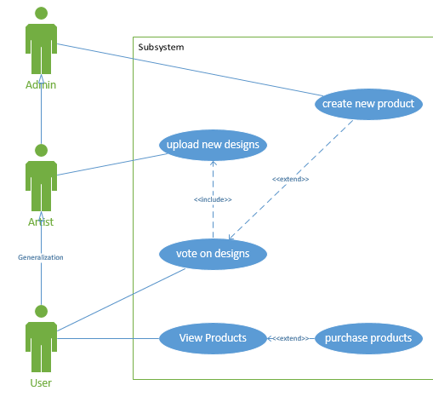

2.8 Documentation requirements
Will be added in the next iteration

2.9 Constraints
There are no hardware limitations. We will have the https protocol which protects user data as well as hashing passwords in the database, which is also secured against SQL injection attacks. We will use the English language.

2.10 Deliverables
As of our project being a website the customer does not have to download and install anything. The website is easily accessible over the internet.

2.11 Assumptions and Dependencies
We shouldn´t have a large problem there, because it is a website and that won´t be affected by different operating systems.

2.12 Apportionment of Requirements
An merchceator where users can create/draw art on their personal merchandise.
They will be able to select the type of clothing and the color.

3 Specific requirements

3.1 External interfaces
Data is sent and queried from the database in the backend using the official C# library for MySQL. The data that is received by the backend and that needs to go to the frontend will be sent as JSON data to the frontend via HTTPS. The frontend code requests data using the backend’s REST API endpoints.

3.2 Detailed functionality description

3.2.1 Function /01/
Users will be able to upload designs they made, which means uploading a png or jpeg, which would then be a design on our products if voted as good enough. Example: Student uploads a design which he made and this will be used as design on t-shirts.

3.2.2 Function /02/
Users will have a site where all the uploaded design are shown. Then they are able to vote for the best ones, which could lead to those which are most voted to being a new desgin for the products.

3.3 Classes and modules
Classes: Admin, Artist, User.
Users Vote, View and purchase the products.
Artist uploads new disigns
Admin restocks old Products and put new ones on the Website.

3.4 Database Requirements

3.4.1 Data model and files
The only files we store are the image files of the submissions.

3.4.2 ER model
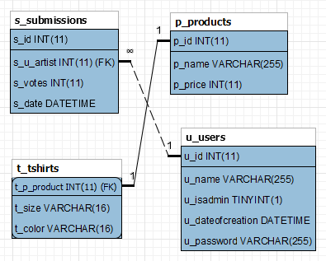

3.4.3 Table definitions
P_products contains information regarding products.
T_tshirts IS A product. It contains extra information only required for this type of product.
U_users contains all user info, including their password.
S_submissions contains all information regarding user’s design submissions.
More to be added

3.5 Performance requirements
It should be able to load within 2 seconds with an adequate internet connection.

3.6 Design constraints
We are trying to use less pictures which should improve performance.

3.7 Quality characteristics, Software system attributes
It should be available all the time unless it is under maintenance. Portability is guaranteed because there will be a mobile view and everyone can use it on his phone unless he doesn´t have internet.

4 Test cases
- User account creation and login.
- Checkout with items in basket
- The voting and uploading system

5 Appendix

5.1 Glossary
Explained in chapter 1.3

5.2 Open topics
Frontend JavaScript Framework not quite clear yet, although it will probably end up being Alpine.

